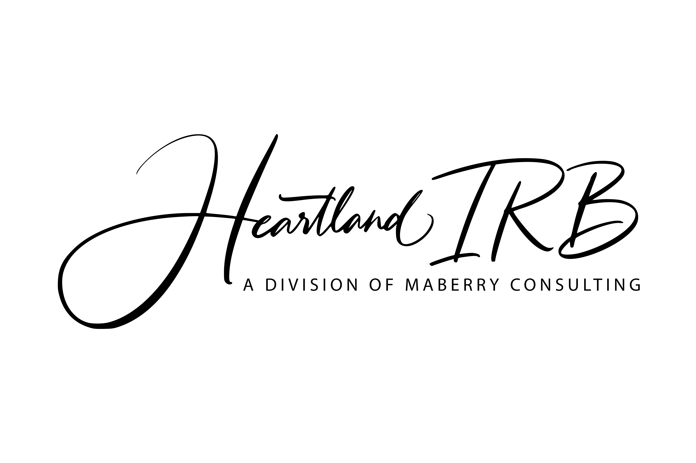
Request for Revisions
- INVESTIGATOR AND STUDY INFORMATION:
Project Title: ____________________________________ HIRB Protocol #: _______
Principal Investigator Name: __________________________________
Telephone contact: __________________________________
Email Address: _____________________________________

- TYPE OF CHANGE REQUESTED (Check all that apply):

- Change in Principal Investigator
Include a summary of changes.

- Protocol revision
Include summary of changes/marked copy of existing protocol and copy of final revised protocol.

- Administrative/Clarification letter revisions
Include a summary of changes.

- Informed consent document revision
Include a copy of document indicating changes (tracked or handwritten changes for minor revisions).

- New or additional informed consent document
Include a copy of new additional informed consent document.

- Recruitment/study informational material revisions
Include a summary of changes/marked copy of existing material and copy of final revised material.

- New or additional recruitment/study informational material

Include a copy of new or additional material.

- Requests for approval of translated documents
- Include copy of translated documents with most current HIRB-approved English version.
- Include affidavit or certification of accuracy from the translator.
- Include copy of the translated document. For consent forms, ensure document is in MS Word or PDF format.
- Other revised items requiring review (Please, describe in the text box below)

