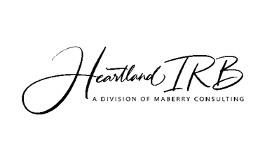
Request for Extension of Research Study or
Program Evaluation
Form

Directions: To request an extension, complete this form and submit it along with any required materials to the current HIRB before expiration. Continuing your research project past its expiration date without an approved extension places the researcher and research project in non-compliance of federal regulations. This puts the researcher at risk of losing any data collected from the time the approval expired until the time it was renewed. Do not forget to take the HIRB certification test on the HIRB website and include your certificate with this form.

- Principal Investigator Name: _______________________________________________
- Project Title: __________________________________ Project HIRB No: ___________
- Date of Initial Project Approval: __/__/____ (mm/dd/yyyy)
- Date(s) of any approved extensions (please, list dates of all approved extensions:
__/__/____ (mm/dd/yyyy) __/__/____ (mm/dd/yyyy)
__/__/____ (mm/dd/yyyy) __/__/____ (mm/dd/yyyy)
- Protocol Update:
  - Has the project protocol been revised for this next year for which you are seeking extension approval?
_____ Yes _____ No
If you answered “No” to question 5.a. above, skip to question 6.
If you answered “Yes” to question 5.a. above go to question 5.b. below.

  - Has this revised project protocol been reviewed and approved by HIRB? _____ Yes _____ No
  - Date of project protocol’s latest revision (if applicable):
__/__/____ (mm/dd/yyyy)
If you answered “No” to question 5.b. above, then when completing this form, send in your revised protocol along with this form. Go to question 6 next.
If you answered “Yes” to question 5.b. above go to question 6 below.

- Have any serious issues or adverse events occurred at any research study/program sites that have not been reported?
_____ Yes _____ No
If you answered “No” to question 6 above, go to question 7.
If you answered “Yes” to question 6, then you must complete an Incident Report Form before applying for renewal. Go to question 7.

- Have any significant protocol violations for this protocol occurred at any of the research study/program sites that have not been previously reported?

_____ Yes _____ No
If you answered “No” to question 7 above, go to question 8.
If you answered “Yes” to question 6, then you must complete an Incident Report Form before applying for renewal. Go to question 8.

- Participant Update:

- About how many participants are currently in your study/program? _____
- Do you plan to increase the number of participants in your study/program for this upcoming year for which you are applying for the extension?

_____ Yes: _____ approximate number of participants to be added _____ No
Statement of Researcher Compliance

Directions: Please read the statement below and initial the line to indicate agreement/compliance. Then, sign and date the form where indicated.
Note: This form section can only be completed by the authorized principal investigator, principal researcher, or program evaluator on this research study.

As Principal Investigator/Principal Researcher/Program Evaluator of this study, I acknowledge the following:

_____ All the information supplied on this form is entirely correct.

__________________________________________ __________
Authorized Researcher/Program Evaluator Signature Date

