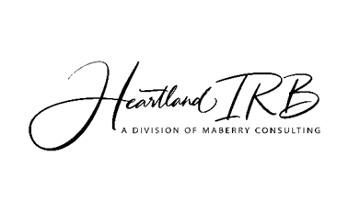

Criminal Background Check Requirement

All individuals who wish to research US public schools during attendance periods must pass a criminal background check run by their local or state police agency. The criminal background check returns data on any convictions an individual has had in that state. If the research or program evaluation project for which you are applying regards the study of minors, Heartland IRB (HIRB) will not approve any research protocol if any researchers or program evaluators applying for said project have been convicted of certain criminal offenses. These criminal offenses concern those that would prevent them from receiving teacher certification in the state in which they wish to perform their research. Examples of such offenses are first-degree murder/manslaughter, attempted first-degree murder/manslaughter, class X felonies, or narcotics or sexual offenses.

Some school districts and/or out-of-school-time programs may even require that a copy of the criminal background check result be retained on file in their offices.

When completing your submission paperwork, you must address this concern in one of the following two ways:
- Have the applicable police agency perform the background check and send an electronic copy of the results with your paperwork to HIRB.
- Complete the HIRB Criminal Background Assurance Form, sign and date the form, and include an electronic copy of this form with your HIRB application.


Criminal Background
Assurance Form

Directions: Please review the statement below and, if it is true, sign and date the form. When applying for a review of a research or program evaluation project, return an electronic copy of this form with your HIRB paperwork.

I, __________________________________________, do hereby establish under penalty of perjury that I have not been convicted of any of the following criminal offenses: first-degree murder/manslaughter, attempted first-degree murder/manslaughter, Class X felonies, or any narcotics or sexual offenses. If a criminal background check were to be performed within the state agency where I am proposing to perform my research and/or program evaluation protocols, no such criminal offenses/convictions would be revealed.

_________________________________ __________
Signature Date

Notarize Here
State of
County of ____

The instrument was acknowledged before me on the _____ date of __________, 20_____, by

___________________________________________________________________________
(Grantors, Settlors, and Beneficiaries)

Notary Public, State of ____________
Commission Expires: _____________
Notary’s Name Typed or Printed: __________________
SEAL

